**Course:** ENSF 337 – Fall 2020

**Lab #:** Lab 8

**Instructor:** M. Moussavi

**Student Name:** Quentin Jennings

**Lab Section:** B03

**Submission Date:** 2020-11-25

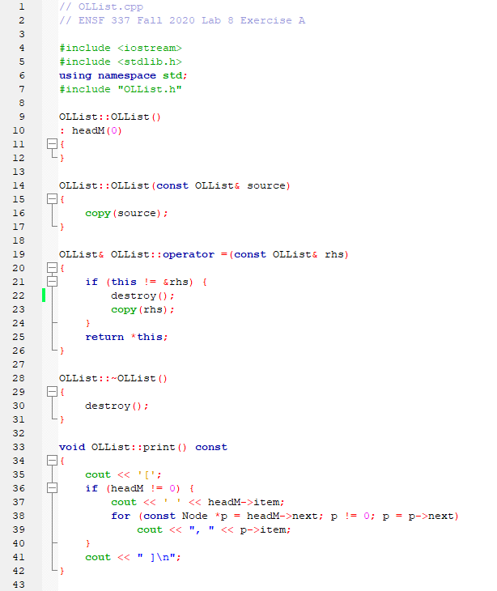**Exercise A OLList.cpp:**

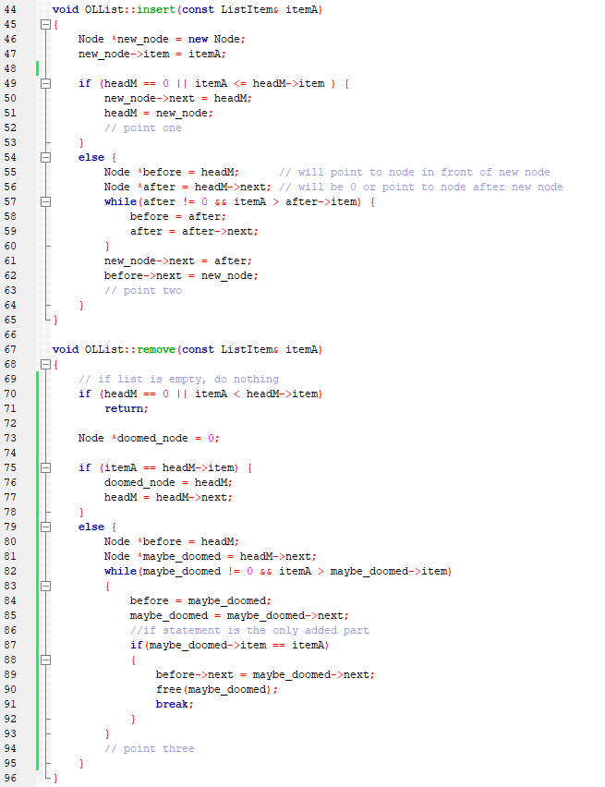

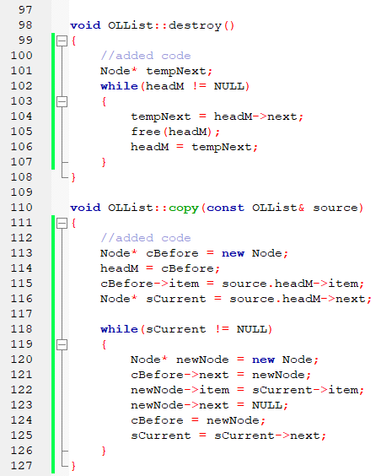

**Exercise A Output:**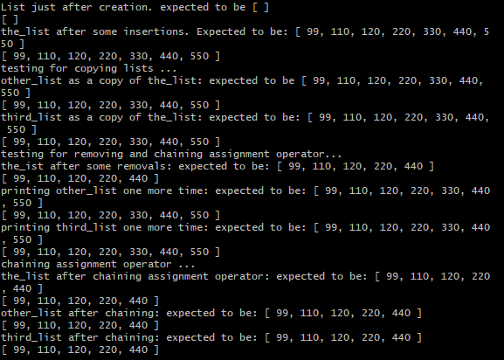

**Exercise B list.h:**

//list.h

//ENSF 337 - Lab 8 Exercise B

//Quentin Jennings

#ifndef list_h

#define list_h

struct ListItem { //structure for the item in a node

int year;

double flow;

};

struct Node { //structure for a node in a linked list

ListItem item;

Node* next;

};

class FlowList { //class for the linked list

public:

FlowList();

void insert(const int srcYear, const double srcFlow);

// A node will be created with a ListItem comprised of the input year and flow.

// The new node will be inserted as to keep the order of the list by year.

bool remove(const int srcYear);

// The list will be traversed until a node with the year is found.

// If said node exists, it is deleted and the before pointer is adjusted.

// Returns true if node is removed, returns false otherwise.

bool exists(const int srcYear)const;

// Returns true if input number srcYear exists within the list.

Node* getHead()const{return head;}

// Getter function for head pointer

private:

Node* head;

// Pointer to the head of linked list

};

#endif

**Exercise B list.cpp:**

//list.cpp

//ENSF 337 - Lab 8 Exercise B

//Quentin Jennings

#include <iostream>

using namespace std;

#include <stdlib.h>

#include "list.h"

FlowList::FlowList(): head(0) {}

void FlowList::insert(const int srcYear, const double srcFlow)

{

//creates the new node to be inserted

Node* newNode = new Node;

newNode->item.year = srcYear;

newNode->item.flow = srcFlow;

//special case needed for if the node is first - the node becomes the new head and the head comes after it

if(head == 0 || srcYear <= head->item.year)

{

newNode->next = head;

head = newNode;

}

//otherwise finds where it needs to be inserted and adjusts next pointers

else

{

Node *before = head; //the node before the new node

Node *after = head->next; //the node after the new node

while(after != 0 && srcYear > after->item.year) //traverses to needed location

{

before = after;

after = after->next;

}

newNode->next = after;

before->next = newNode;

}

}

bool FlowList::remove(const int srcYear)

{

//if the list is empty, do nothing

if(head == 0 || srcYear < head->item.year)

{

return false;

}

Node *delete_this = 0;

//if the head needs to be deleted

if(srcYear == head->item.year)

{

delete_this = head;

head = head->next;

}

//otherwise, checks the rest of the list and marks the node to be deleted if found

else

{

Node *before = head;

Node *current = head->next;

while(current != 0 && srcYear > current->item.year)

{

before = current;

current = current->next;

}

if(current != 0 && current->item.year == srcYear)

{

before->next = current->next;

delete_this = current;

}

}

if(delete_this==0)

return false;

else

{

free(delete_this);

return true;

}

}

bool FlowList::exists(const int srcYear)const

{

//checks head first

if(srcYear == head->item.year)

return true;

//then checks rest of list, similar to remove function

else

{

Node* current = head->next;

while(current != 0 && srcYear > current->item.year)

current = current->next;

if(current != 0 && current->item.year == srcYear)

return true;

}

return false;

}

**Exercise B hydro.h:**

//hydro.h

//ENSF 337 - Lab 8 Exercise B

//Quentin Jennings

#include "list.h"

#ifndef hydro_h

#define hydro_h

void displayHeader();

//displays intro screen

int readData(FlowList& source);

//reads and records years/flows into the flow list, returns # of records

int menu();

//displays the menu, returns user's choice (1-5)

void display(const FlowList* source, int num);

//displays the years, flows, and average of the flows (calls average)

void addData(FlowList* source, int &numRecords);

//prompts the user to enter new data, inserts data into linked list, updates # of records

void removeData(FlowList* source, int &numRecords);

//prompts user to indicate a year to be removed, removes it from the list, updates # of records

double average(const FlowList* source, int num);

//returns average flow of given list

void saveData(const FlowList* source);

//opens flow.txt file for writing and writes contents of linked list into the file in same format

void pressEnter();

//prompts user to press enter to continue, uses cin.get() to stall

void clearCin();

//clears the cin stream

#endif

**Exercise B hydro.cpp:**

//hydro.cpp

//ENSF 337 - Lab 8 Exercise B

//Quentin Jennings

#include <fstream>

#include <stdlib.h>

#include <iomanip>

#include <iostream>

using namespace std;

#include "hydro.h"

#define VERSION "1.0"

#define LABSECTION "03"

#define PROGRAMNAME "Flow Studies - Fall 2020"

#define FILENAME "flow.txt"

int main(void)

{

FlowList List;

int numRecords;

displayHeader();

numRecords = readData(List);

while(1)

{

switch(menu())

{

case 1: //displays flow list and avg

display(&List, numRecords);

break;

case 2: //adds a data node to list

addData(&List, numRecords);

break;

case 3: //saves data into file

saveData(&List);

break;

case 4: //removes a data node from list

removeData(&List, numRecords);

break;

case 5: //terminates program

cout << "\nProgram terminated.\n";

return 0;

default: //invalid input

cout << "\nError: Invalid input. (should be 1, 2, 3, 4, or 5)\n";

break;

}

//clears the stream and waits for a response after each selection

clearCin();

pressEnter();

}

}

void displayHeader()

{

cout << "Program: " << PROGRAMNAME << endl;

cout << "Version: " << VERSION << endl;

cout << "Lab Section: B" << LABSECTION << endl;

cout << "Produced By: Quentin Jennings" << endl;

pressEnter();

}

void pressEnter()

{

cout << "\n<<< Press Enter to Continue >>>\n";

cin.get();

}

int readData(FlowList& source)

{

ifstream inStream (FILENAME);

if(inStream.fail())

{

cout << "Error: File " << FILENAME << " not found, could not read data. Closing program.\n";

exit(-1);

}

int yr;

double fl;

int num = 0;

while(!inStream.eof())

{

inStream >> yr;

inStream >> fl;

source.insert(yr, fl);

num++;

}

inStream.close();

return num;

}

int menu()

{

cout << "Please select one of the following operations:\n";

cout << "1. Display flow list and the average flow.\n";

cout << "2. Add data to the flow list.\n";

cout << "3. Save data into file.\n";

cout << "4. Remove data from the flow list.\n";

cout << "5. Quit Program.\n";

cout << "\nEnter your choice (1, 2, 3, 4, or 5):\n";

int n = 0;

cin >> n;

return n;

}

void display(const FlowList* source, int num)

{

cout << "Year: Flow: (billions of cubic meters)\n";

Node* current = source->getHead();

while(current != 0)

{

cout << setw(10) << left << current->item.year << setiosflags(ios::fixed) << setprecision(2) << current->item.flow << endl;

current = current->next;

}

cout << "\nThe annual average of the flow is: " << setiosflags(ios::fixed) << setprecision(2) << average(source, num) << endl;

}

double average(const FlowList* source, int num)

{

double sum = 0;

Node* current = source->getHead();

while(current != 0)

{

sum += current->item.flow;

current = current->next;

}

return sum / num;

}

void addData(FlowList* source, int &numRecords)

{

int yr;

double fl;

cout << "\nPlease enter a year: ";

cin >> yr;

if(source->exists(yr))

{

cout << "\nError: data already exists for the year " << yr << ".\n";

}

else

{

clearCin();

cout << "Please enter the flow: ";

cin >> fl;

source->insert(yr, fl);

numRecords++;

cout << "\nNew data record inserted successfully.\n";

}

}

void removeData(FlowList* source, int &numRecords)

{

int yr;

cout << "\nPlease enter a year: ";

cin >> yr;

if(source->remove(yr))

{

numRecords--;

cout << "\nData node successfully removed.\n";

}

else

cout << "\nData node not removed as no node was found for the year " << yr;

}

void saveData(const FlowList* source)

{

ofstream outStream("flow.txt");

if(outStream.fail())

{

cout << "Error: File output stream unsuccessful. Closing program.\n";

exit(-1);

}

Node* current = source->getHead();

while(current != 0)

{

outStream << setiosflags(ios::fixed) << setprecision(2) << current->item.year << " " << current->item.flow << endl;

current = current->next;

}

outStream.close();

cout << "Data successfully saved into " << FILENAME << ".\n";

}

void clearCin()

{

cin.clear();

while((getchar()) != '\n');

}

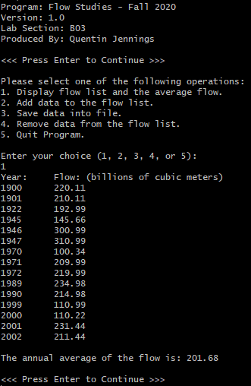**Exercise B Program Outputs:**

